Ануфриев Андрей 465029 28.03.2025

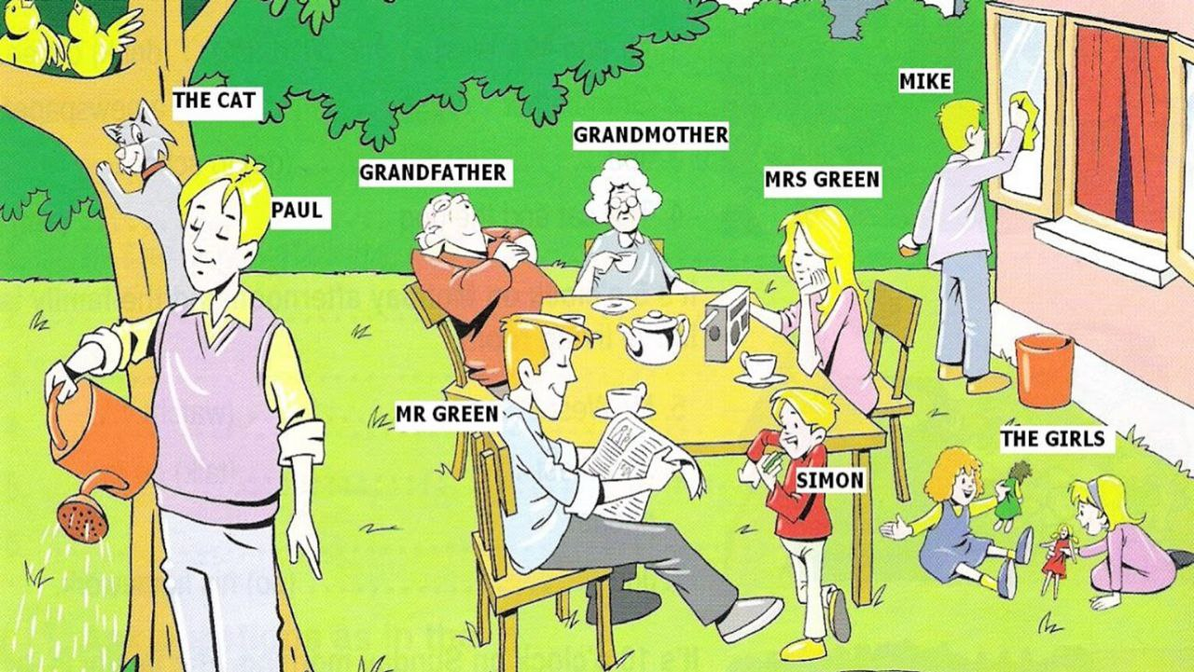

1. **Grandmother**
   * **Clothes:** She is wearing a **blue dress** and **black shoes**.
   * **What is she doing?** She is **sitting in a chair and smiling**.
2. **Grandfather**
   * **Clothes:** He is wearing a **red shirt**, **brown trousers**, and **glasses**.
   * **What is he doing?** He is sleeping.
3. **Mrs. Green**
   * **Clothes:** She is wearing a **pink blouse**.
   * **What is she doing?** She's tuning up the radio.
4. **Mr. Green**
   * **Clothes:** He is wearing a grey-blue **shirt** and **grey** pants.
   * **What is he doing?** He's reading the newspaper.
5. **Paul**
   * **Clothes:** He is wearing a pink vest, yellow shirt and grey trousers.
   * **What is he doing?** He's watering the flowers.
6. **The Girls**

* **Clothes:** One girl is wearing a blue dress, the other is wearing a pink dress.
* **What are they doing?**  They're playing with dolls.

1. **Mike**

* **Clothes:** He's wearing a white T-shirt, gray pants, and orange shoes.
* **What is he doing?**  He's cleaning the window.

1. **Simon**

* **Clothes:** He's wearing a red sweatshirt, white pants, and yellow pants.
* **What is he doing?**  He's eating candy.

1. **The Cat (Mixie)**
   * **Clothes:** No clothes! (Cats don’t wear clothes!)
   * **What is it doing?** It is hunting birds.